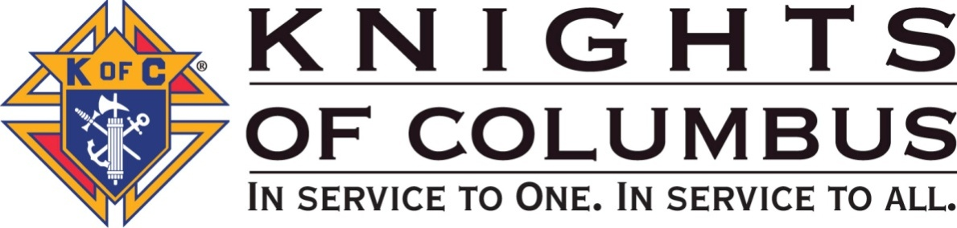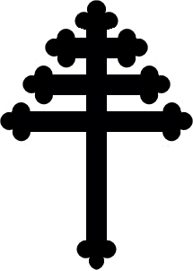

ST. MARON COUNCIL #12640 OF FAYETTEVILLE, NC
ST. MICHAEL THE ARCHANGEL MARONITE CATHOLIC CHURCH

